**LAB : 6**

**OBJECTIVE :**

1. Draw a sequence diagram for the warehouseOnFire scenario. Include the objects bob ,alice ,john , FRIEND , and instances of other classes you may need. Draw only the ﬁrst ﬁve message sends. In addition to the UML rules on sequence diagrams, all correct sequence diagrams for this exercise should include one or more actors on the left of the diagram who initiate the scenario, one or more objects in the center of the diagram which represent the system, and a dispatcher actor on the right of the diagram who is notiﬁed of the emergency. All actors and objects should be instances
2. Draw a sequence diagram for the ReportIncident use case of Figure 6-1. Draw only the first five message sends. A correct solution should include a FieldOfficer actor on the left, a Dispatcher actor on the right, and one or more classes in the middle representing the FRIEND system. The answer to this exercise should be consistent with the answer to the previous exercise, in the sense that all class and operation names should be the same

**Requrements :**

(a) Windows PC (Windows 7/8/10) / Mac

(b) Star UML Tool

**Sequence Diagram :**

1. **6.1**

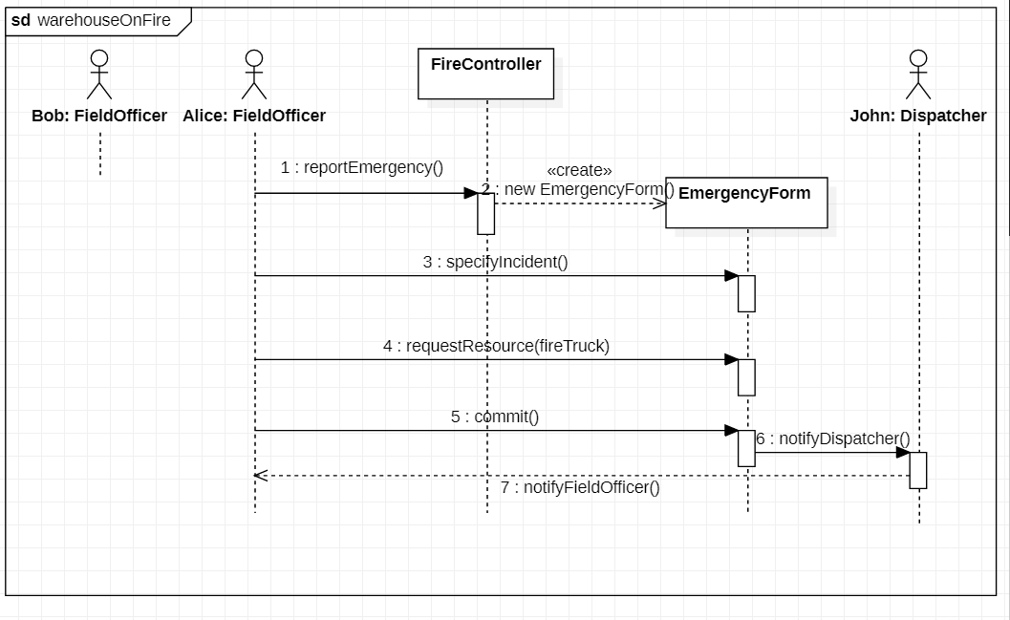

1. **6.2**

